Logistics application assignment

1. Create an application name logistic application
2. Create object name as:

* Customer details
* Assert and driver
* Quote
* Invoice
* Status

1. Customer location and management:

* Address
* City
* Postal code
* Province
* Street
* Name
* Quantity
* Product
* Email

These details are filled by administrator, the page is created with LWC.

And the data is uploaded on object.

* Updating record of unit price based on product chosen:

Mobile-10k

Tablet-15k

PC-25k

Mac-50k

1. Quote management

Creating quote whenever the customer detail is entered

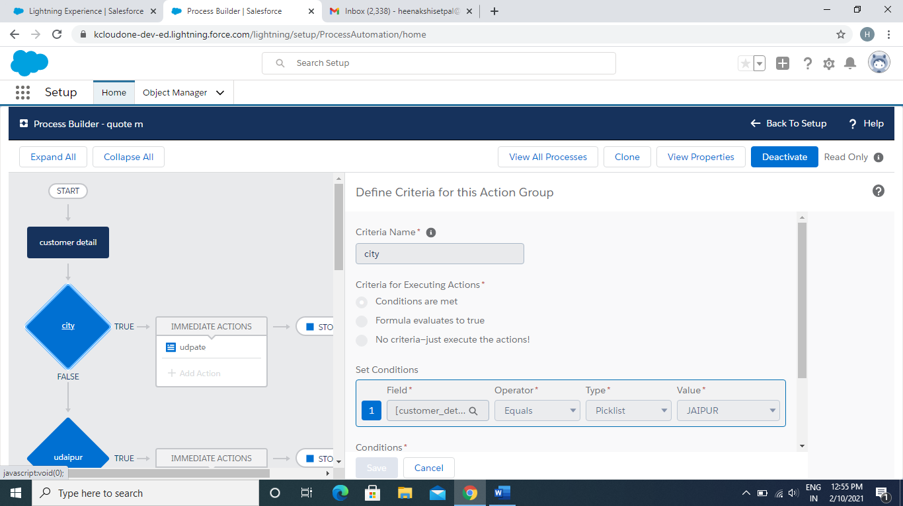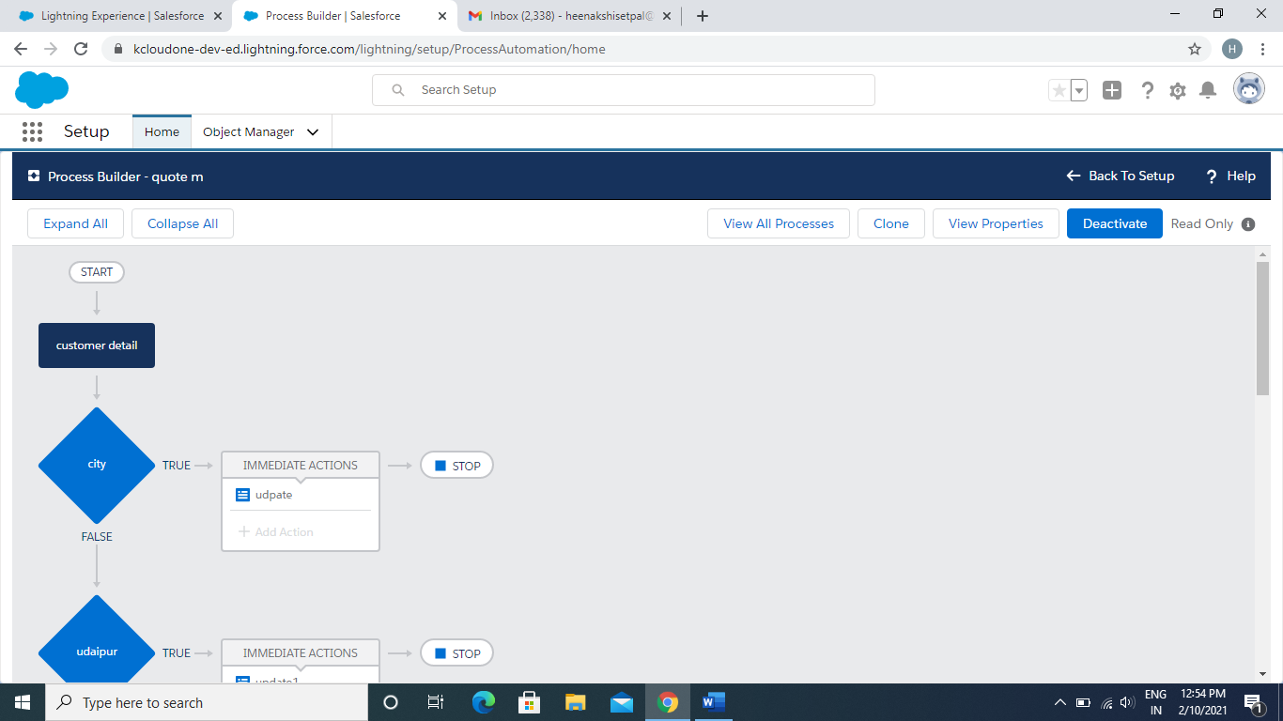

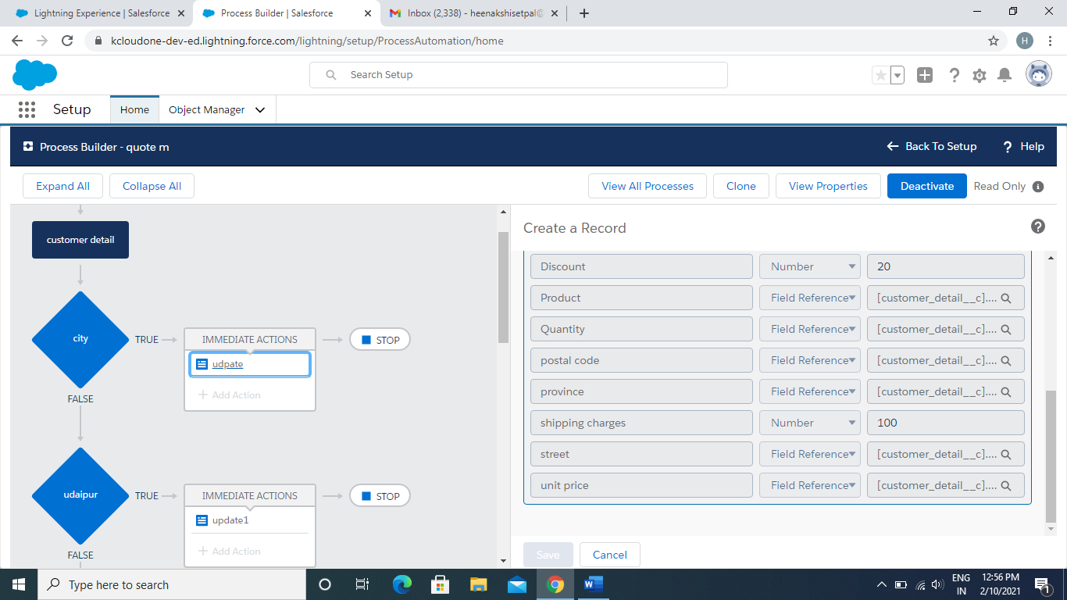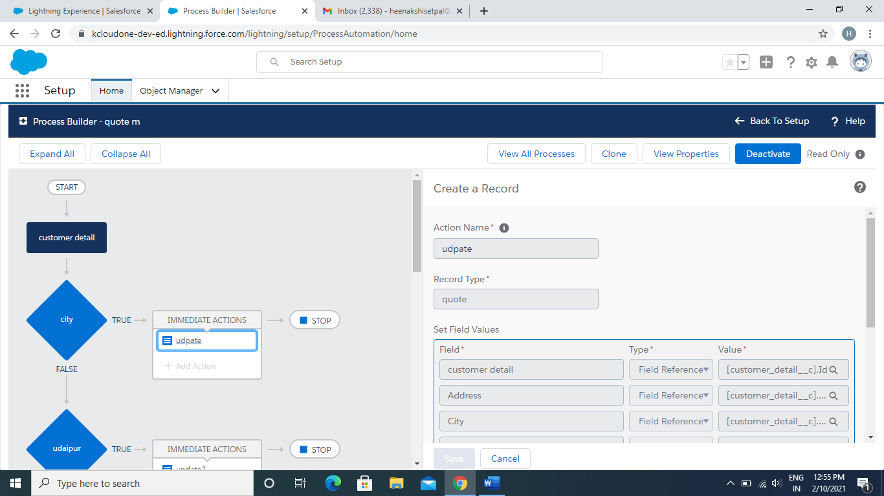

Similarly, whenever city is:

Udaipur: discount will be given as 12%

Shipping charges:100

Mumbai: discount :25%

Shipping charges:120

Pune: discount :30%

Shipping charges:150

Kolkata: discount :30%

Shipping charges:130

1. Assert and driver management:

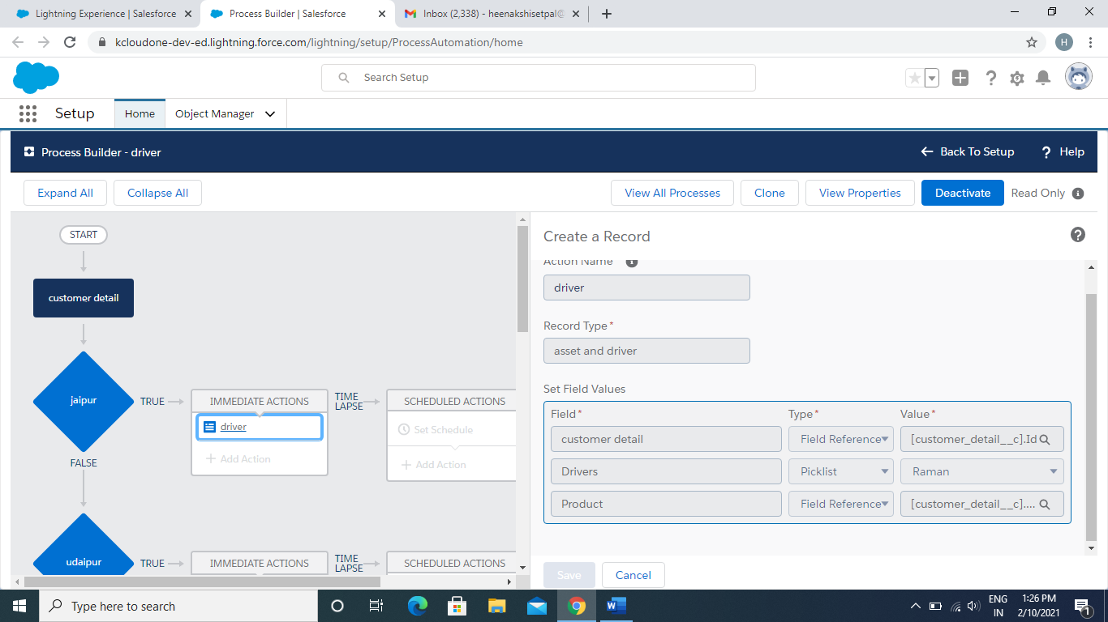Driver are assign according to location:

Jaipur: driver name: Raman

Udaipur: Driver name: Vijay

Mumbai: Driver name: Ram

Pune: Driver name: Kailash

Kolkata : driver name:Mangal

1. Invoice :

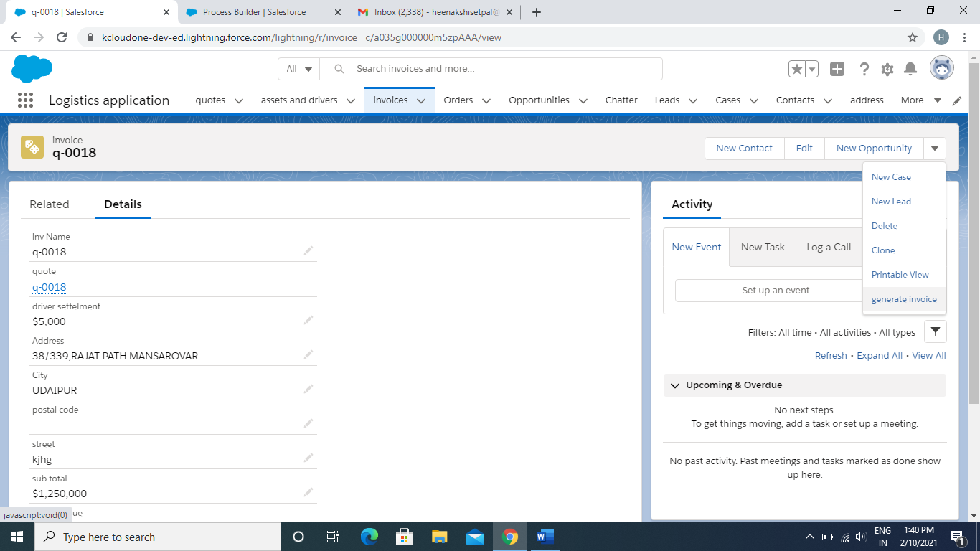Invoice record will create when a quote is generated

By clicking on generate invoice button the invoice will be generated which is designed in visual force page

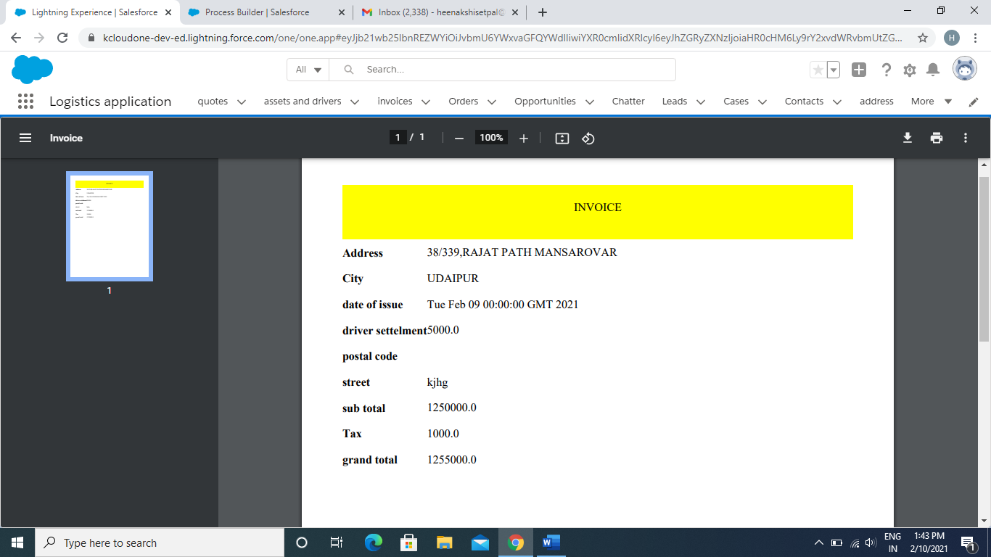

Code for visualforce page:

<apex:page renderAs="pdf" standardController="invoice__c" >

<div style="background-color:yellow;">

<h1>

<center>

INVOICE

</center>

</h1><br></br>

<br></br>

</div>

<apex:pageBlock >

<apex:pageBlockSection >

<apex:outputText value="{!invoice__c.Address__c}">

</apex:outputText><br></br><br></br>

<apex:outputText value="{!invoice__c.City__c}">

</apex:outputText><br></br><br></br>

<apex:outputText value="{!invoice__c.date_of_issue__c}">

</apex:outputText><br></br><br></br>

<apex:outputText value="{!invoice__c.driver_settelment__c}">

</apex:outputText><br></br><br></br>

<apex:outputText value="{!invoice__c.postal_code__c}">

</apex:outputText><br></br><br></br>

<apex:outputText value="{!invoice__c.street__c}">

</apex:outputText><br></br><br></br>

<apex:outputText value="{!invoice__c.sub_total__c}">

</apex:outputText><br></br><br></br>

<apex:outputText value="{!invoice__c.Tax__c}">

</apex:outputText><br></br><br></br>

<apex:outputText value="{!invoice__c.grand_total__c}">

</apex:outputText><br></br><br></br>

</apex:pageBlockSection>

</apex:pageBlock>

</apex:page>

1. Dashboard:

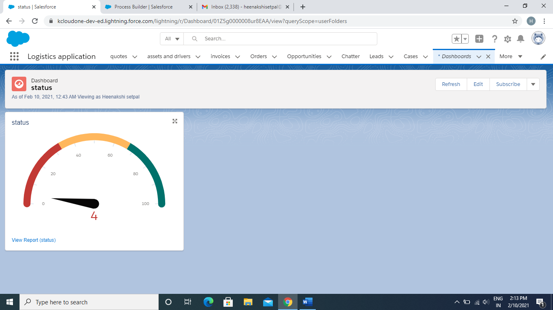

1. Keep updated to customer:

In this the workflow on created on status object

So whenever status will be create or update the mail to send to email

